**COMP 3059 – Capstone Project I**

**Software Requirements Analysis and Design Assignment**

This assignment is an overview to gather the software needs with requirements analysis and help to proceed with the design.

The requirements analysis helps to break down functional and non-functional requirements to a basic design view to provide a clear system development process framework. It involves various entities, including business, stakeholders and technology requirements.

The design is the activity following requirements specification and before programming. Software design usually involves problem solving and planning a software solution.

To work on this assignment you could use the references and a sample template given below. The sample template can be customised to suit the nature of your project.

Reference Readings/Example:

<http://www.uacg.bg/filebank/acadstaff/userfiles/publ_bg_397_SDP_activities_and_steps.pdf>

<http://gmitweb.gmit.ie/pdunne/sweng/03-Requirements.pdf>

[www.cse.msu.edu/~chengb/RE-491/Papers/SRSExample-webapp.doc](http://www.cse.msu.edu/~chengb/RE-491/Papers/SRSExample-webapp.doc)

<https://nces.ed.gov/pubs2005/tech_suite/part_2.asp>

Reference template:

[www.tricity.wsu.edu/~mckinnon/cpts322/cpts322-srs-v1.doc](http://www.tricity.wsu.edu/~mckinnon/cpts322/cpts322-srs-v1.doc)

# 1.0 Introduction

## Purpose

This document will provide a detailed description of the cultural exchange system. It will explain the software requirements for its intended audience, more specifically, what the system will do, the scope, the constraints, and the capabilities. Both the stakeholders and developer can reference to this document during the developing phase and onward. The cultural exchange system will be capable for accommodate up to 100,000 user cases at the same time, accessing its cooperative system.

## Scope

The Culture Forum will have at least 2 main sections of wiki separated by country: China and Canada. This feature might be adjusted by the end of the scope based on how many countries will be listed on initiation as well as how they will be presented.

A registration system that allows users to input basic personal information as well as their country of origin and countries of interest. This information will be publicly displayed that the user can contact individuals directly using our messaging function. This feature might be altered based on the basic information required for registration.

A discussion board that allows user to post threads and comment on other public posts

A cultural event list and event calendar for user meetups

# System Overview

## Project Perspective

The cultural exchange system is a new self-contained system. There will be four actors and one cooperating system in total. The four actors include Members, guests and Event Admins, and site admin. The former three can access the cooperative system through internet. Site admin can access the system directly. As a system, the cultural exchange will have three components to deliver its functionality:

1. Cultural Wiki

A information based system were members are allowed to suggest edits, and create content for a specific country that they are familiar with.

1. Cultural Forum

A forum platform that allows member to start a thread and reply to other peoples threads regarding any topic of their interest, as long as it is related to the country they specified.

1. Cultural Event.

A cultural event system that provides a platform for members/ event admin to create off-line meet up events in the cities they choose.

## System Context

Countries across the globe have vastly different cultural and customs. Many travellers or temporary residents are unaware of local customs. There are resources on the internet that focuses on specific countries, but never centrally. This is where our cultural exchange system comes in place. It provides a platform for people to learn about country specific information, connect with authentic local residences, and ask fellow foreigner questions. Members around the globe can connect to people either through posting threads on forum or participate in off-line meet up events. The offline events also create a pathway for our company to venture into other business opportunities.

## General Constraints

As stated in the earlier section, the scope of our current system will focus on information for two of the countries. This in fact is one of our biggest constraint. It takes massive amount of research and information to kickstart our platform which means the resources need to be invested prior to the launch. The business itself, it takes monitoring to ensure that member edits are getting filtered and approved. In addition, even though we included a sensitive word filter in our forum platform, some may post thread with inappropriate content. It takes manpower to manage and monitoring the forum.

Another constraint is related to the interaction that we designed. Member class have the ability to submit edits to wiki for approval by the site admin. However, it is a tremendous amount of manpower to approve all the changes that members are making. As the wiki expands, the number of edits or suggestions will grow exponentially.

On the other hand, it is up to the members of this system to ensure a dynamic interaction. If not many users are posting threads or meet up events, our cultural exchange system will not reach its full potential and provide value.

It is in our best effort to keep all contents on the platform true and free of bias. However, since members have the freedom to edit or suggest edit. Sometimes the content may derail from the truth, which can be misleading for some of the other user.

Events that are organized by event admin are a sole responsibility of the organizing individual. As a company, we don’t have the control over how the meet up events are carried out. This may be unsecure for some of the member that learns the event opportunity from our platform.

## Assumptions and Dependencies

We assume that during the initiation of the project, all user will be actively participating in the wiki and the forum. Our contents rely heavily on the case users access and contributing to the contents on our cultural exchange system. We are dependent on members to post threads and to edit on our wiki to expand our contents. Without meaningful and interactive participation from our user, we will not be able to reach our desired result with is to strengthen the exchange of country specific cultural, and to provide guidance to travellers or temporary visitors.

We are also assuming that members are conscious of local law and regulations. All the offline Meet up posted on our platform are secure and free of criminal offences. It is up to the members to organize these events; therefore we assume they will not abuse this system for their personal gain.

## 3.0 Functional Requirements``

This section describes specific features of the software project. If desired, some requirements may be specified in the use-case format and listed in the Use Cases Section.

## 3.0 Functional Requirements``

This section describes specific features of the software project. If desired, some requirements may be specified in the use-case format and listed in the Use Cases Section.

### 3.1.1 <Functional Requirement or Feature #1>

**Wiki**

* Introduction
  + A wiki for users to find country specific information. This wiki can list all the local cultures. User can learn about the regional culture they like according to their own preferences.
* Inputs
  + Site Admin can upload and update information about wiki (Cultural information)
* Processing
  + The system uploads the modified results.
* Outputs
  + Users and guest will see the right information. The website will be updated to the latest results.

### 3.1.2 <Functional Requirement or Feature #2>

**Discussion board**

* Introduction
  + A discussion board where users can post questions and get responses from other users. Users can make group to off-line activity.
* Inputs
  + Users are free to post and free to comment on other people's posts.
* Processing
  + The system uploads the modified results.
* Outputs
  + Users and guest will get the right information. The website will be updated to the latest results.

### 3.1.3 <Functional Requirement or Feature #3>

**Event Calendar**

* Introduction
  + Users can view the time of the event. You can also create new events. Other users can book an event.
* Inputs
  + Users can book event and create event.
* Processing
  + The system uploads the modified results.
* Outputs
  + Users User successfully booked event .

## 3.2 Use Cases

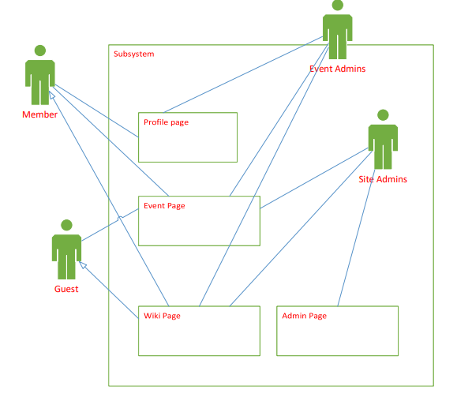

**Use case # 1 Member**

**3.2.1 Use Case: Login**.



Brief description:

Users log into the site to see their custom profiles.

Initial step by step description.

Before this use case can be initiated, the user must sign up and become a member.

1. The user logs in with username and password.

**3.2.2 Use Case: Search events:**



**Brief description:**

The member accesses the events page and searches an event and can choose to attend it.

**Initial step by step description.**

Before this use case can be initiated the member must be logged in.

1. The user searches by event name, category or keyword.
2. The system displays all events with matching criteria.
3. The member clicks the event they are interested in
4. The member is displayed info about the event and can confirm attendance.
5. Member can now post on the events forum page.

**3.2.3 Use Case: Leave event comment\rating:**



**Brief description:**

After a member has attended an event they can leave comments and ratings.

**Initial step by step description.**

Before this use case can be initiated the member must be logged in and have attended a previous event.

1. Member attends an event.
2. The next day a Member can leave a comment and\or a rating for other members and guests to see on the events forum page.

**Use Case: Browse or edit cultural wiki.**



**Brief description:**

A member can browse the sites cultural wiki or they can feel free to edit it and help the community.

**Initial step by step description.**

Before the member can edit the wiki, they must be logged in. A guest user can still browse but not edit the page.

1. Member enters the cultural wiki page and can search by keyword or name.
2. If they have found the desired info (ie. County or cultures wiki) they can click an edit button under the section the wish to edit.
3. Edit is sent to the site admins for fact checking and approval.

**Use Case: Edit Profile Page:**



**Brief Description:**

A member can log in and customise their bio and profile information.

**Initial step by step description.**

Before the member can edit their profile page they must be logged in.

1. Member logs on.
2. Clicks on their profile.
3. Clicks the edit button on the part they want to edit
4. Edit screen opens where they can add new information to replace the old info.

**Use case # 2 Event admin**

**Use Case 3.2.5: Create Event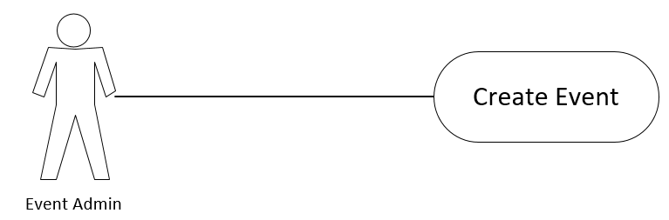 Brief description:**

An Event Admin can create an event.

**Initial step by step description.**

Before this use case can be initiated the event admin must be logged in.

1. Event admin logs in
2. Clicks on events
3. Clicks the create event button
4. Edits the event information
5. Saves the event to event page

**Use Case 3.2.6: Join event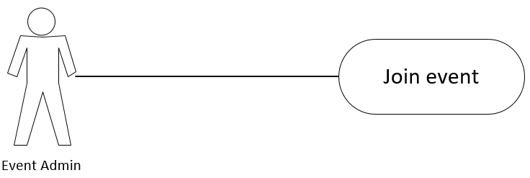 Brief description:**

An Event Admin can join an event.

**Initial step by step description.**

Before this use case can be initiated the event admin must be logged in.

1. Event admin logs in
2. Clicks on events
3. Clicks on an event he/she is interested in
4. Clicks on join event button

**Use Case 3.2.7: Communicate with member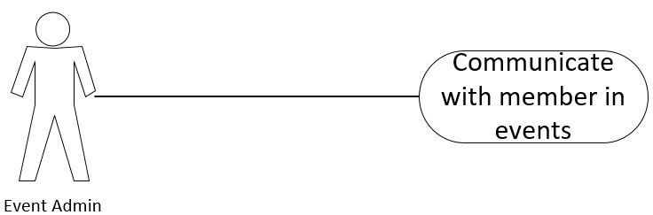 Brief description:**

An Event Admin can communicate with other members in an event.

**Initial step by step description.**

Before this use case can be initiated the event admin must be logged in.

1. Event admin logs in
2. Clicks on events
3. Clicks on an events attending
4. Clicks on participants
5. Clicks on a member’s profile
6. Click on chat button on member’s profile

**Use Case 3.2.8: View and Reply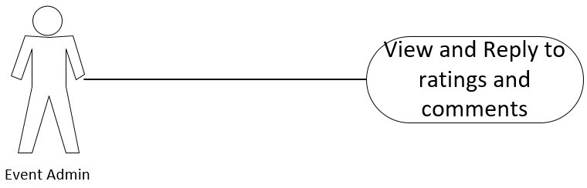 Brief description:**

An Event Admin can view and reply to ratings and comments on events.

**Initial step by step description.**

Before this use case can be initiated the event admin must be logged in.

1. Event admin logs in
2. Clicks on events
3. Clicks on an event he/she has attended
4. Clicks on reviews to view ratings and comments
5. Clicks on reply to reply to a rating or comment

**Use Case 3.2.9: Reject members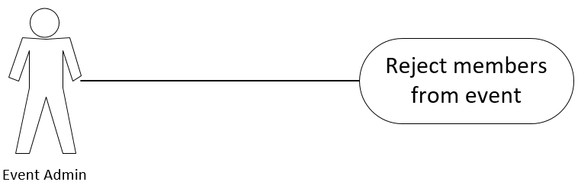 Brief description:**

An Event Admin can reject members from events depending on their behaviour.

**Initial step by step description.**

Before this use case can be initiated the event admin must be logged in.

1. Event admin logs in
2. Clicks on events
3. Clicks on participants
4. Clicks on a x symbol beside member’s name
5. Confirms to remove user or cancel

**Use case # 3 Guest**

**Use Case 3.2.11: Browse Events**

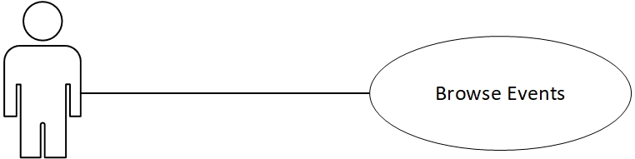

**Brief description:**

Guest can browse cultural events but can not attend.

**Initial step by step description.**

Guest can browse cultural events anytime and do not need log in.

1. Guest can clicks on Cultural page
2. Guest can clicks on an article
3. Guest can clicks on cultural events

**Use Case 3.2.12: Browse Cultural wiki**

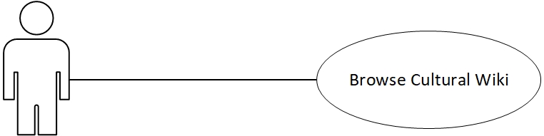

**Brief description:**

Guest can browse cultural Wiki but can not attend.

**Initial step by step description.**

Guest can browse cultural Wiki anytime and do not need log in.

1. Guest can clicks on Wiki page
2. Guest can clicks on an article
3. Guest can clicks on cultural Wiki

**Use case # 4 Site Admin**

**Use Case 3.2.13: Access Database**

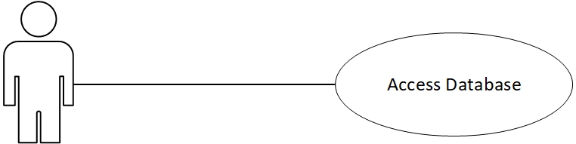

**Brief description:**

Admin can access database to control Web and database and all information.

**Initial step by step description.**

Before the Admin can access the database, they must be logged in.

1. Site admin log in to admin page.

2. Clicks on Admin Page

3. Site upload data.

4. remove data.

**Use Case 3.2.14: Change layout site  
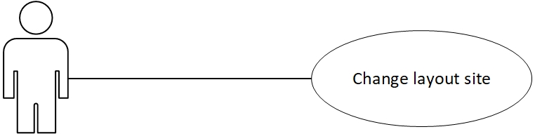  
  
Brief description:**

An Site Admin can Change layout Site.

**Initial step by step description.**

Before this use case can be initiated the Site admin must be logged in.

1. Site admin logs in
2. Change web site layout
3. Upload layout in Website maintenance time.

**Use Case 3.2.15: Global Access  
  
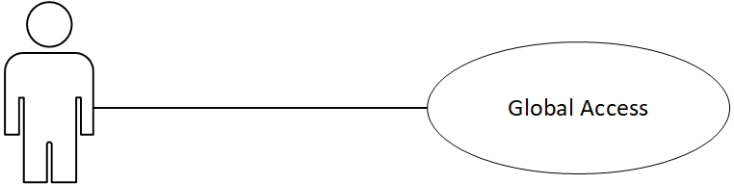  
Brief description:**

An Site Admin can Have access to all web pages.

**Initial step by step description.**

Before this use case can be initiated the Site admin must be logged in admin page.

1. Site admin log in

2. Clicks on Wiki page

3. Clicks on Event page

4. Clicks on an Article

5. Clicks on cultural Wiki

6. Clicks on cultural Event

7. Clicks on Admin Page

**Use Case 3.2.16: Monitor site and control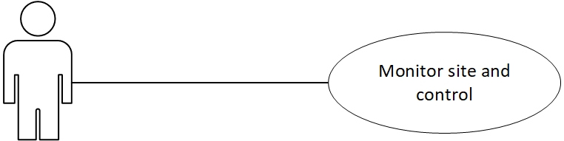 Brief description:**

An Site Admin can Monitor site and makes sure rules are followed.

**Initial step by step description.**

Before this use case can be initiated the Site admin must be logged in admin page.

1. Site admin logs in

2. Global access

3. Monitor site maker sure user followed.

4. delete error event and information.

5. Communicate with users and The user can be alerted when an error occurs.

**3.3 Data Modelling and Analysis**

* Normalized Data Model Diagram

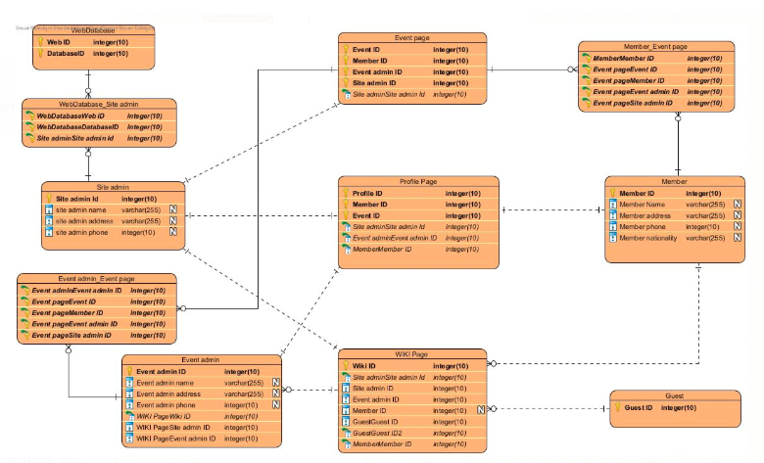

* Activity Diagrams

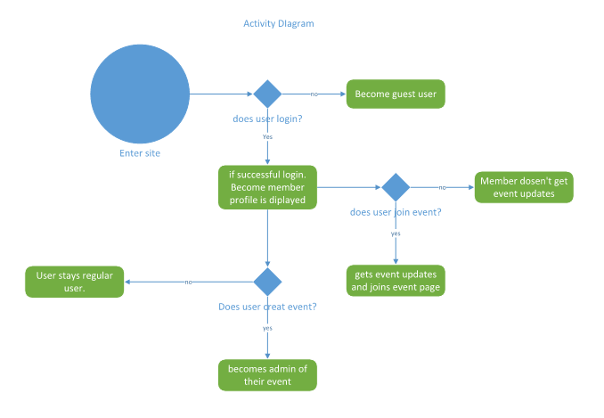

* Sequence Diagrams

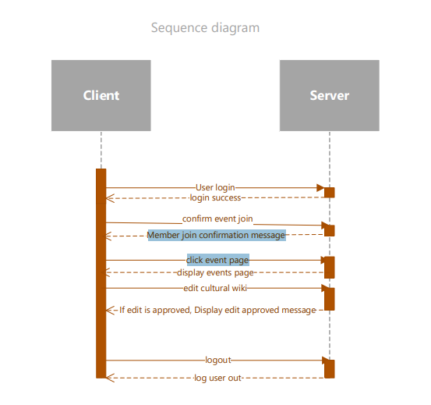

* UML Class Diagram

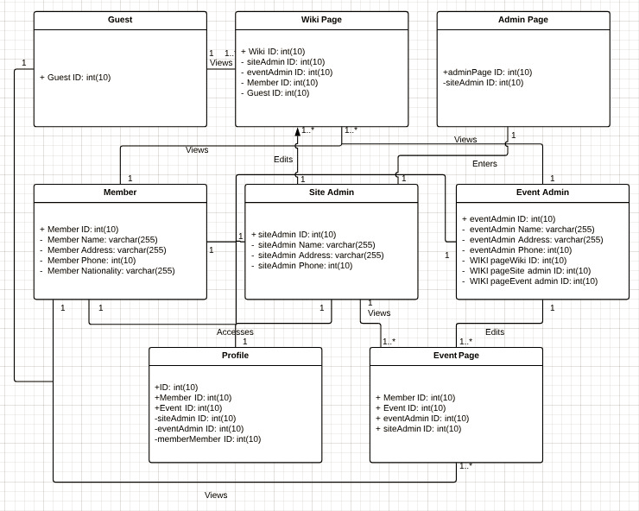

**3.4 Process Modelling**

* Data Flow Diagram

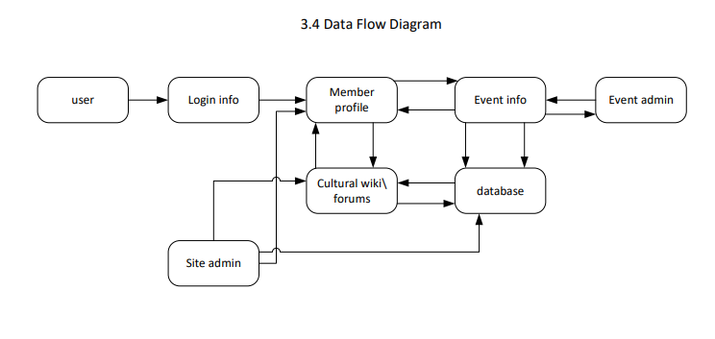

# 4.0 Non-Functional Requirements

System Requirements to help improve functionality, efficiency and Security.

* A Guest will not be able to modify or reply to any events created in the system.
* Events cannot be held within less than 48 hours of being posted.
* There only be one event creator per event.
* Donations to events will take 24 hours to process for security purposes.
* Each Member will have a public profile viewable for all users (excluding guests)
* Each System Administrator must be verified by the apps developers.
* Events will be specific to member location, ex: A user from Ontario will only be able to view events held in Ontario. This will help with processing time for the event feed and messaging.
* Searches will be based on event categories and key words in each event.

## 5.0 Logical Database Requirements

Will a database be used? If so, what logical requirements exist for data formats, storage capabilities, data retention, data integrity, etc?

* As new cultures are added to the system, the file database will need to grow equally as much.
* There will be 3 separate databases, 1 for a user profile, 1 for the different cultures, and 1 for the events.
* Each database will have its selection of subqueries depending on each database’s variables.
* The Cultures database will be viewed globally while the Event and profile database will only be viewable only by members.
* Only System Administrators will have read/write capabilities of all 3 databases.
* The Culture query can only be modified by the Administrators

## 6.0 Other Requirements

- For safety purposes a user will be able to discontinue their account after creation, but they will not be able to permanently delete their information.

- All voluntary donations will be processed through Paypal.

- A reminder email will be sent to each member attending an event 1 week before to ensure attendance.

- Only Event Administrators and System Administrators can kick members from specific events for any reason they see fit.

- Upon creation event information can be dynamically changed by the Event Administrator as often as desired.

.

**7.0 Approval**

The signatures below indicate their approval of the contents of this document.

|  |  |  |  |
| --- | --- | --- | --- |
| Project Role | Name | Signature | Date |
| Team Leader | Youquan Liu-101078710 |  | Nov/03 |
| Team member | Anthony Caldwell-101085288 |  | Nov/03 |
| Team member | Qian Wang-100961367 |  | Nov/04 |
| Team member | Ryan Haberle-101094993 |  | Nov/04 |
| Team member | Tiago Sa-101054051 |  | Nov/04 |